CS-23334 FUNDAMENTALS OF DATA SCIENCE
ASHWIN C 240701058

Experiment 8 Date: 18.09.2025

Experiment to understand Logistic Regression for a given data set.

Aim:
To conduct an experiment to understand Logistic Regression for a given dataset

Description:
Understand Logistic Regression algorithm for a given dataset

Algorithm:
Step 1: Define the Classification Problem and Select Features
Step 2: Split the Dataset into Training and Testing Sets
Step 3: Train the Logistic Regression Model
Step 4: Predict and Evaluate Model Performance
Step 5: Interpret Coefficients and Visualize Results

About Dataset:
This dataset represents user information with attributes including User ID, Gender, Age, Estimated Salary, and a binary Purchased indicator showing whether the user made a purchase (1) or not (0).
Code With Output:

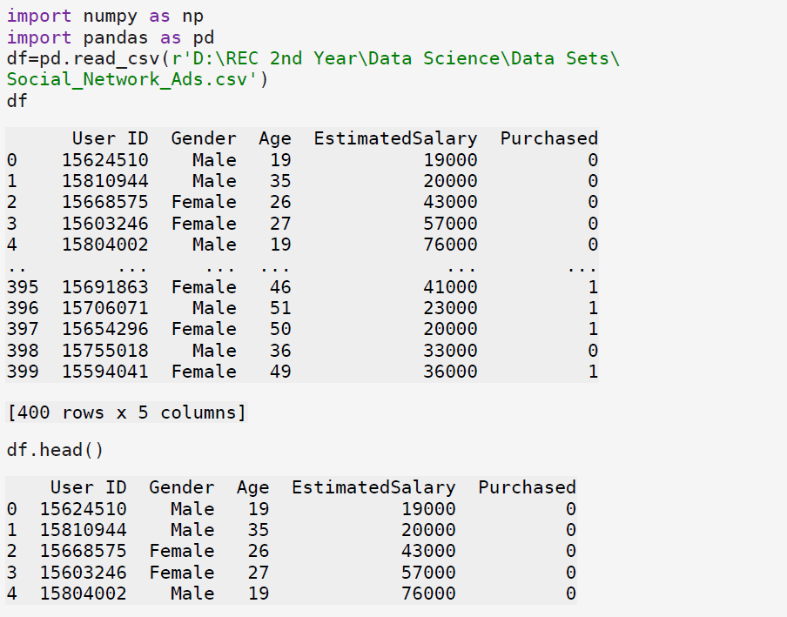
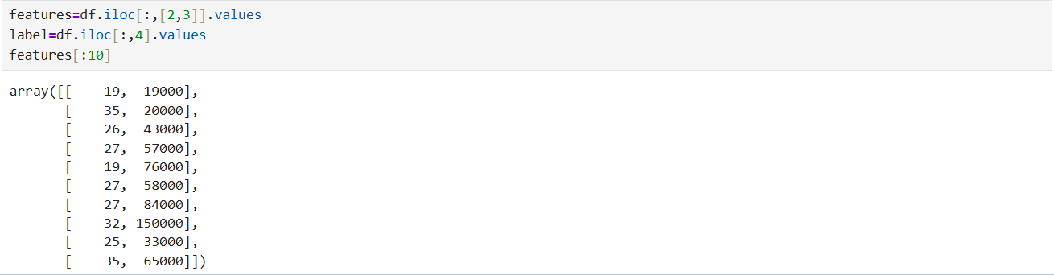

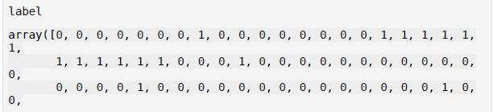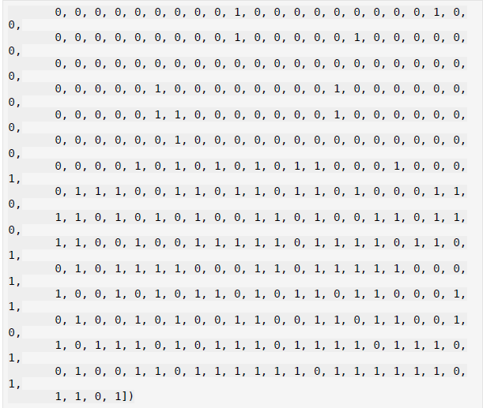
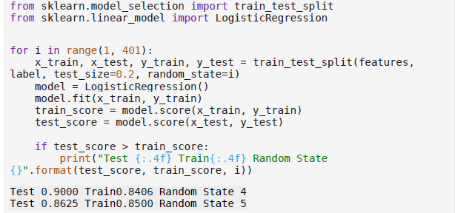

Result:
Thus experiment was conducted to understand logistic regression for a dataset

